4. System Architecture

Overview
This system is a distributed three-tier architecture consisting of a presentation tier, an application tier, and a data tier.
The Presentation tier, implemented using React, is the layer with which clients interact. It houses the user interface and communicates with the application tier through two channels: a WebSocket connection for all core marketplace features, and HTTP REST calls for the three bonus web service features.
The Application tier is the heart of the system and contains all business logic. Unlike a traditional monolithic backend, the application tier is divided into three distinct components to satisfy the requirement of low-level socket communication while maintaining a clean and organized structure.
The Socket Server, implemented in pure Java with raw TCP sockets and no frameworks, serves as the core of the system and handles all nine marketplace features. The Bridge Server, also implemented in pure Java, acts as a protocol translator between the React frontend's WebSocket connection and the Socket Server's raw TCP interface, since browsers are inherently unable to open direct TCP connections.
The Spring Boot REST Server is implemented as a bonus component and exposes three selected features as standard REST web service endpoints, communicating with the Socket Server via TCP to execute the required logic without duplicating any business logic.
The Data tier contains all the data needed for the system. It is powered by CockroachDB, a distributed SQL database, and communicates with the Socket Server through the JDBC API. The database is partitioned across multiple nodes to ensure horizontal scalability and fault tolerance.

High Level Architecture Diagram
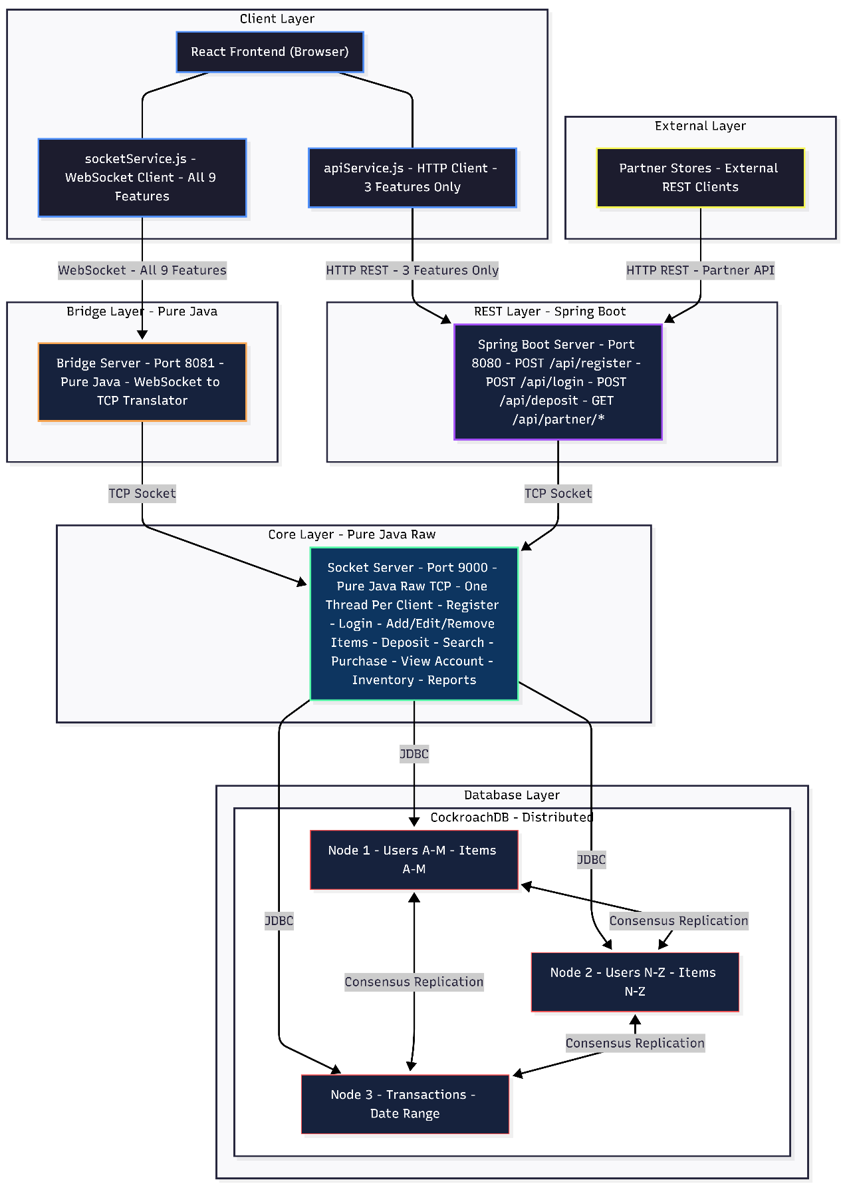
Figure 1: High Level System Architecture

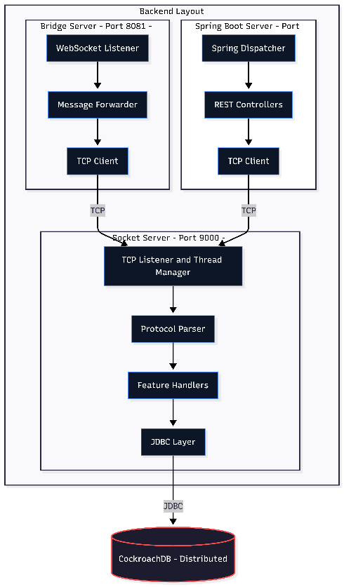
Detailed Backend Layout
Figure 2: Backend Higher level Architecture

Internal Modules
The backend is structured into three separate components, each with a distinct responsibility and internal organization.

Socket Server
The Socket Server is the core of the entire system. It is implemented using pure Java raw TCP sockets with no frameworks, in direct compliance with the project requirement for low-level socket communication. It is internally structured into handlers and services to achieve separation of concerns.
When a client connects, the server spawns a dedicated thread to handle that connection, allowing multiple clients to be served concurrently. The Protocol Parser reads the incoming message in the format COMMAND|{JSON}, identifies the command, and routes the request to the appropriate handler. Each handler delegates the business logic to its corresponding service, which then interacts with CockroachDB via JDBC.
- The Protocol Parser reads raw TCP messages and routes them to the correct handler.
- The Handlers receive parsed requests and delegate to the service layer.
- The Services contain all business logic, validate conditions, and coordinate with the database.

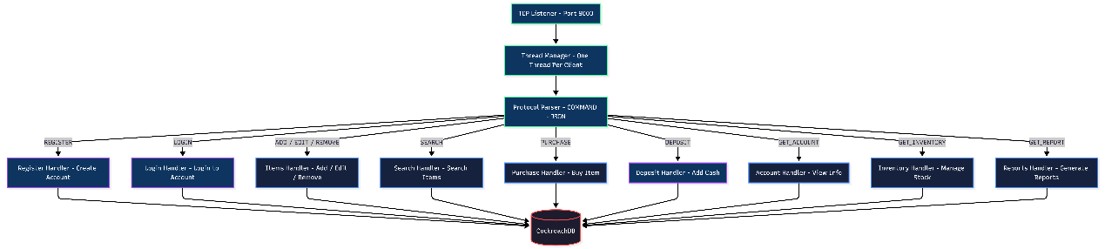
Figure 3: Socket Server Internal Architecture

Bridge Server
The Bridge Server is implemented in pure Java and contains zero business logic. Its sole responsibility is to maintain a WebSocket connection with the React frontend and forward all messages to the Socket Server over TCP, then relay the responses back to the browser. It exists purely to bridge the gap between the browser's WebSocket protocol and the backend's raw TCP protocol.
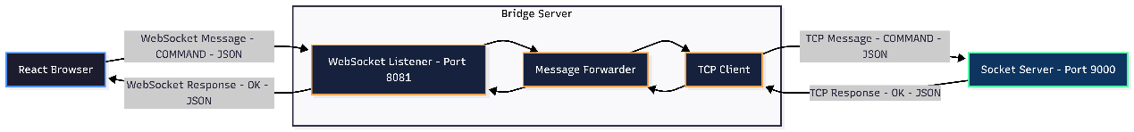
Figure 4: Bridge Server Internal Architecture

Spring Boot REST Server
The Spring Boot REST Server is implemented as a bonus component and exposes three marketplace features as standard REST endpoints. Each controller receives an HTTP request, builds the equivalent TCP protocol message, forwards it to the Socket Server, receives the TCP response, and returns it as a clean HTTP JSON response to the caller. This design ensures that all business logic remains exclusively in the Socket Server, and the REST server acts purely as an additional entry point into the same core logic.
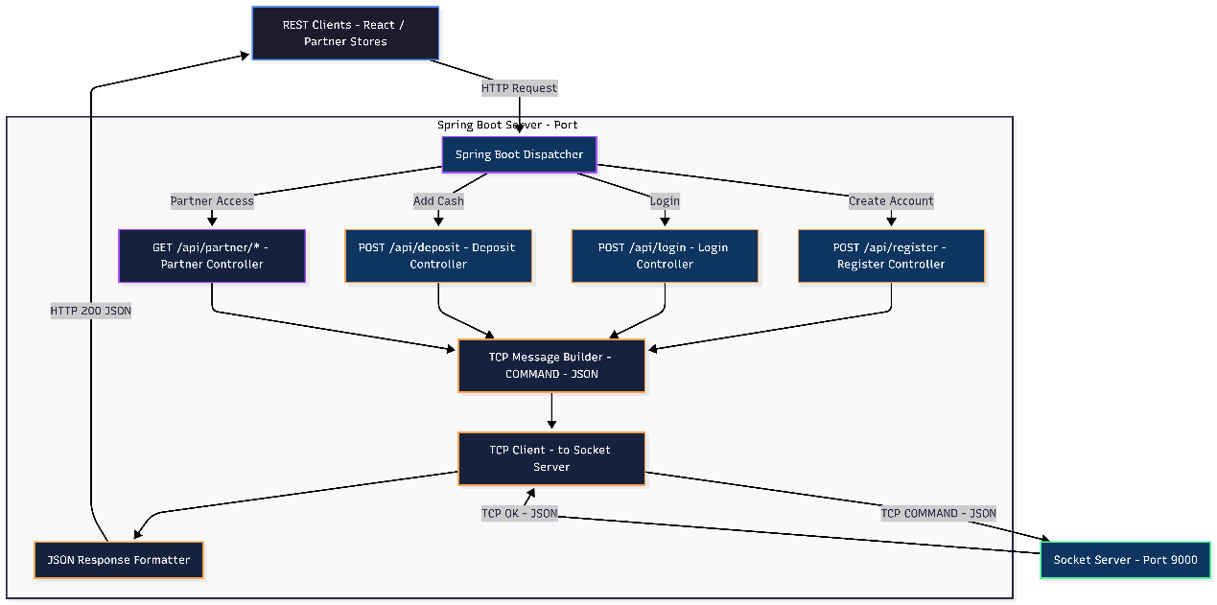Figure 5: Spring Boot REST Server Internal Architecture

React Frontend
The React frontend is internally organized into screens and service modules. The socketService.js module manages the WebSocket connection to the Bridge Server for all nine core marketplace features. The apiService.js module handles HTTP REST calls to the Spring Boot server for the three bonus features. This separation ensures that each communication channel is managed independently and cleanly.
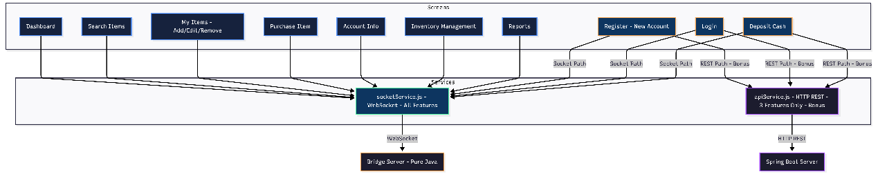
Figure 6: React Frontend Internal Architecture

Shared Models
Common models are centralized and shared across backend components to avoid redundancy and improve consistency. They represent the core business objects of the system stored in the database.
The design rule is that any model used by multiple modules is placed in the shared models, while models used by only one module remain local to that module.
Shared Entities:
- User
- Item
- Transaction
- Inventory
Shared DTOs:
- UserResponseDto
- ItemDto
- TransactionDto
DTOs are used to transfer structured data between backend components and the frontend without directly exposing internal entity classes.
Custom Exceptions:
- InsufficientBalanceException
- ItemNotFoundException
- UserNotFoundException
- UnauthorizedActionException
These custom exceptions provide clear and reusable error handling across all backend components.

Three Features Implemented as REST (Bonus)
Register was chosen because it is the entry point of the entire system, and every other feature depends on having an account. It demonstrates a complete web service cycle: receiving, validating, and processing input, then returning a structured response. It requires no prior state or authentication, making it the simplest possible standalone web service.
Login was chosen because it demonstrates token-based authentication, which is a core distributed systems concept directly relevant to this project. It shows how stateless authentication works across a distributed environment — the server issues a token and never needs to store session state, which is fundamental to scalability.
Deposit was chosen because it demonstrates a transactional web service that validates authorization via JWT, performs a state-changing operation on the database, records an audit trail in the transactions table, and returns a confirmation. This covers more web service concepts than a simple read operation and directly demonstrates distributed database consistency in action.

REST Implementation
The three bonus features are implemented using REST via Spring Boot, which provides native REST support through standard HTTP. Data is exchanged in JSON format, which is lightweight, human readable, and integrates directly with the React frontend without any transformation layer.
SOAP was considered but rejected because it requires a separate Spring-WS dependency, a WSDL file describing every operation, XML schemas for every request and response, and a completely different controller model. Every request and response must be wrapped in a heavy XML envelope, and the React frontend cannot consume SOAP directly without an additional translation layer. This adds complexity that is not justified given that the system does not require any of SOAP's specific advantages.

Benefits of This Architecture
- Security: The React frontend has no direct database access. All data flows through the Socket Server, which acts as a mandatory gateway for authentication, authorization, and input validation.
- Compliance: The core application is built entirely on raw TCP sockets with no frameworks, satisfying the project requirement for low-level socket communication.
- Testability: Each tier and each internal component can be tested in isolation, allowing failures to be precisely located without ambiguity.
- Modularity: Separating the frontend, bridge, socket server, REST server, and database into distinct components makes the system easier to organize and understand. Within the backend, the handler and service structures further improve modularity.
- Maintainability: Handlers and services each have a specific responsibility, making the code easier to maintain and extend as the system grows.
- Reusability: The shared models package allows common entities, DTOs, and exceptions to be reused across multiple components without duplication.
- Scalability: CockroachDB supports horizontal scaling and distributed storage, making the data tier more scalable than a traditional single-node database.

